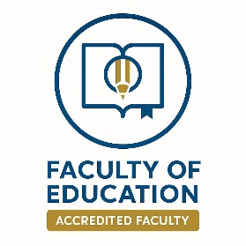

Mohamed Abdelkader Abdelghaffar | Name |  |  |  |  | 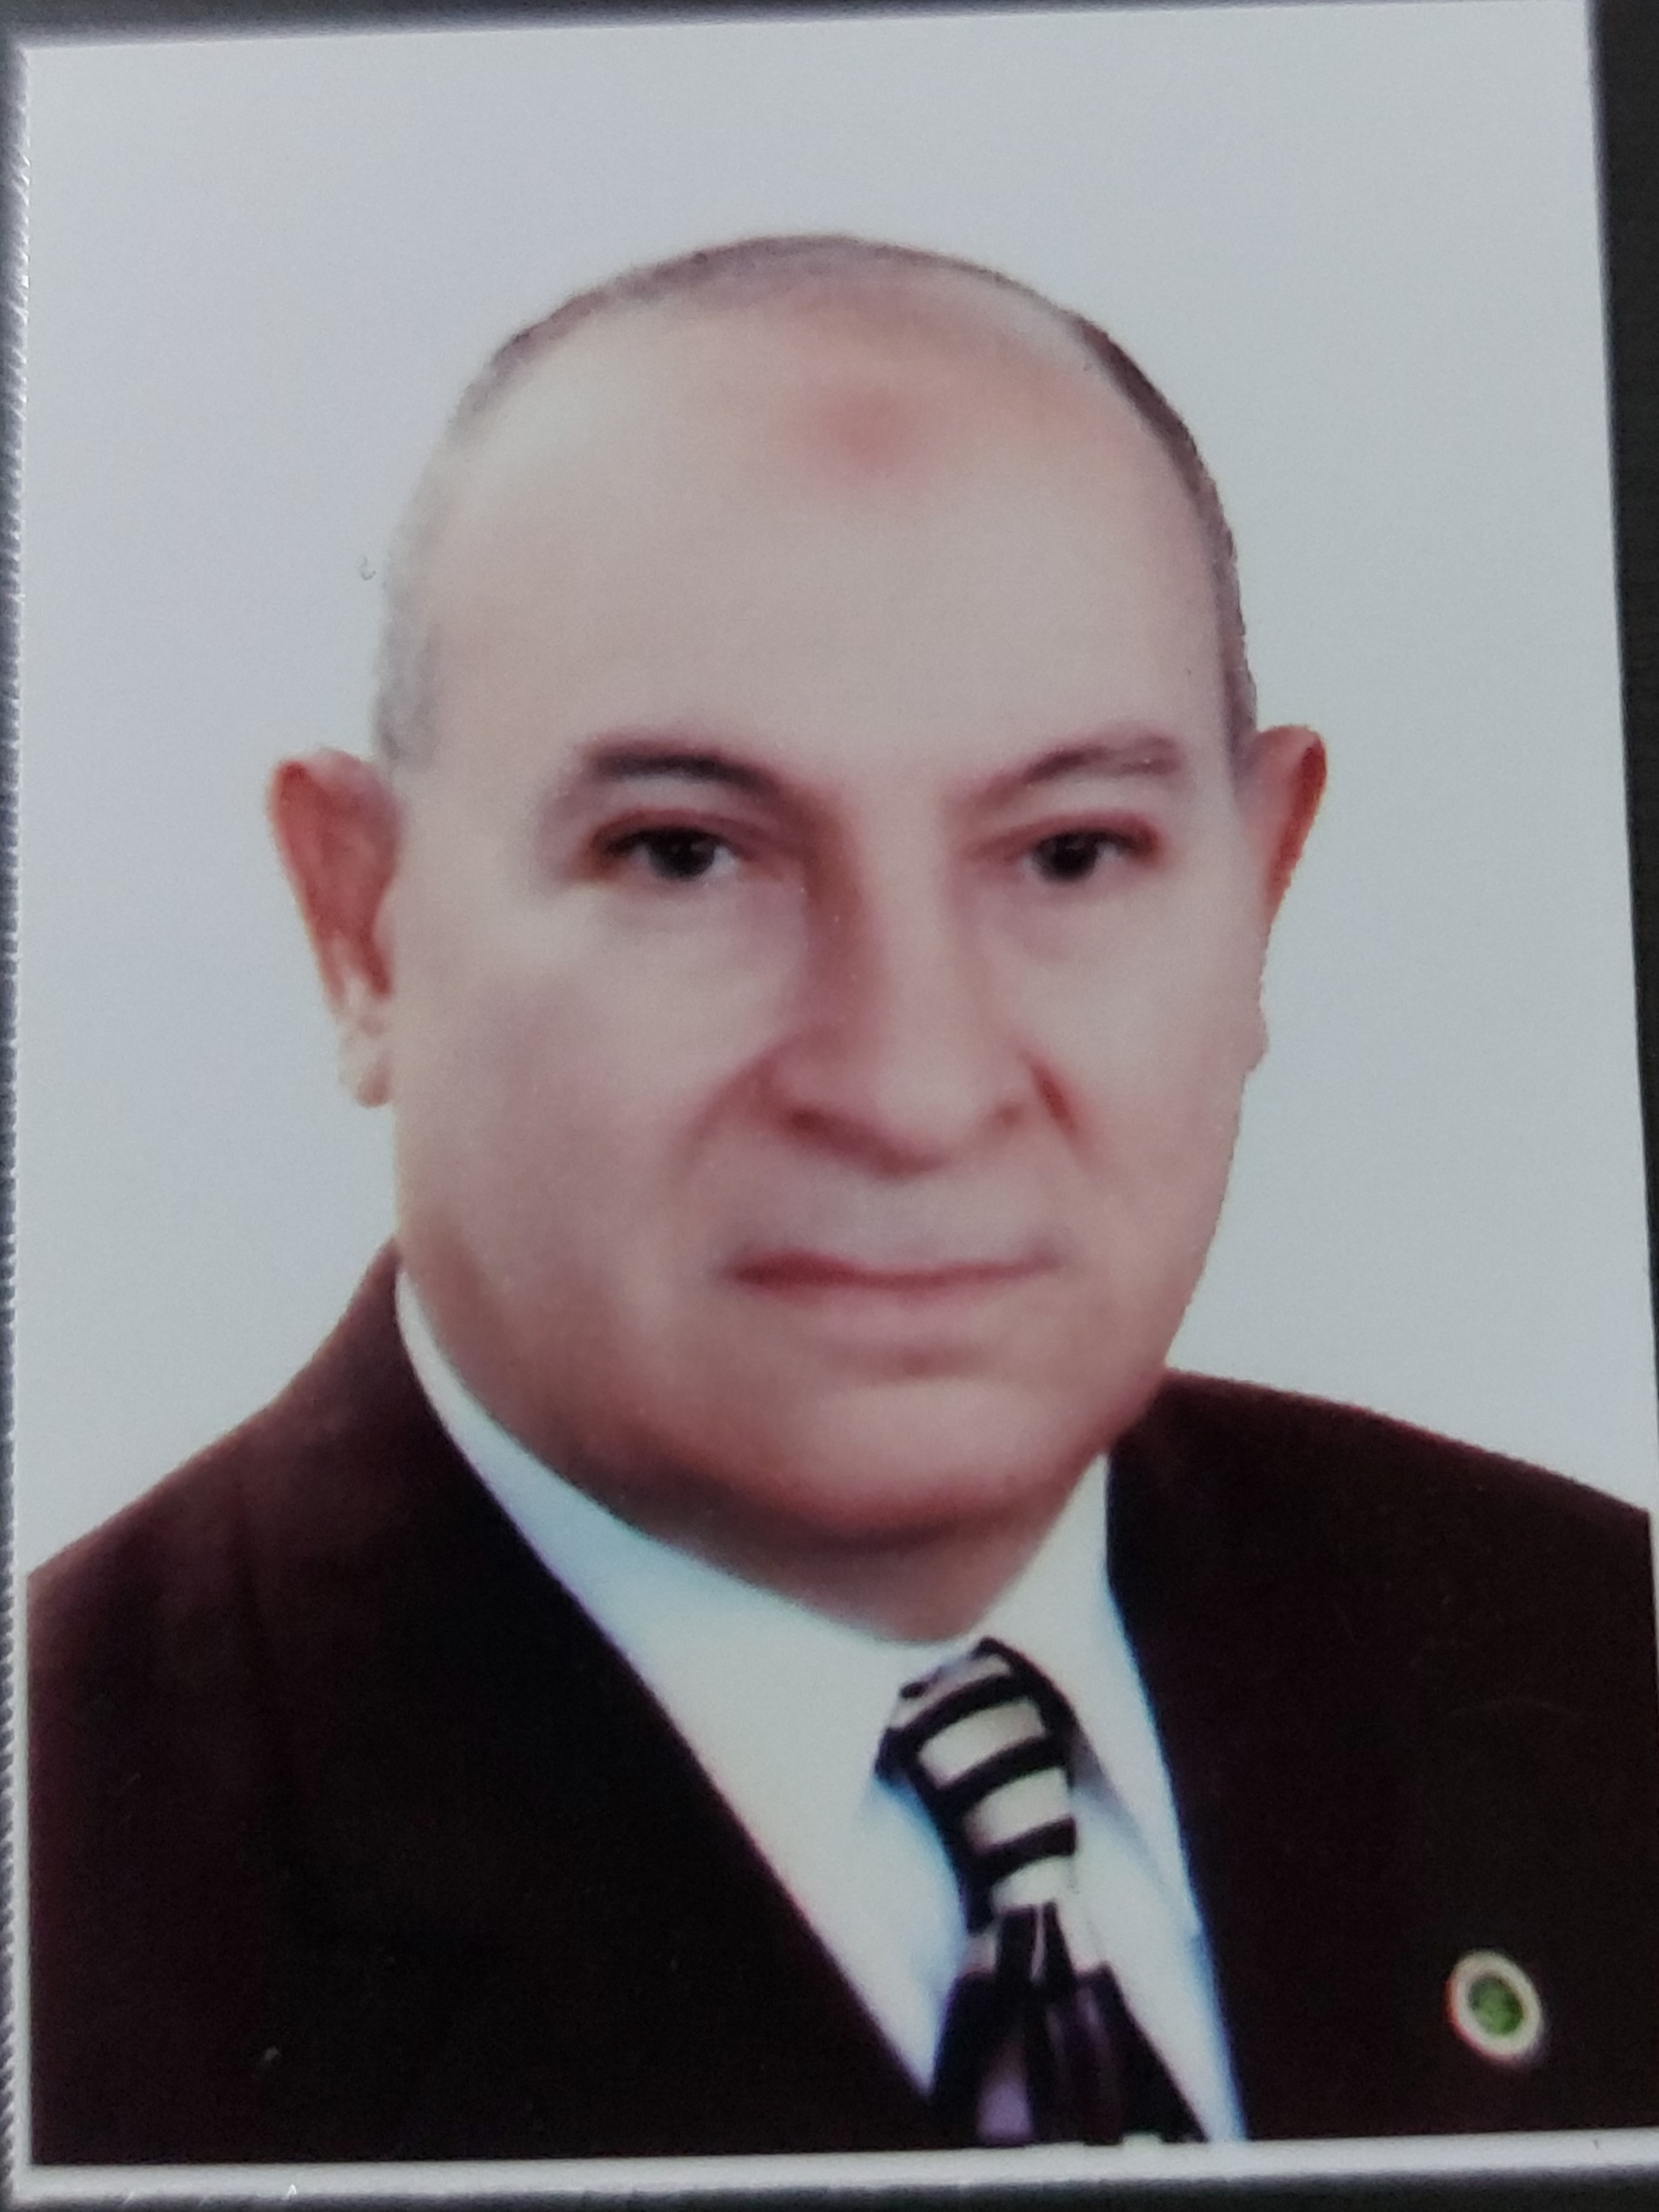
Mohamed Abdelkader Abdelghaffar | Name used in scientific publication
Emeritus Professor, Department of Educational Psychology – Faculty of Education, Helwan University | Current Job and Job
Ph.D., Helwan University, Egypt | Degree  (Name of University and State)
Educational Psychology |  |  | General Specialization
Educational Psychology |  |  | Specific Specialization
Mghaffar01@gmail.com |  | Email
Bachelor of Science and Education (Physics & Chemistry), Faculty of Education, Ain Shams University, 1970.  Special Diploma in Education, Faculty of Education, Ain Shams University, 1972.  Master’s Degree in Education (Educational Psychology), Faculty of Education, Ain Shams University, 1975.  Ph.D. in Philosophy of Education (Educational Psychology), Faculty of Education, Mansoura University, 1979. |  | Academic Qualifications
Teacher at the Ministry of Education from 03/09/1970 to 21/05/1977.  Teaching Assistant, Faculty of Education, Mansoura University from 22/05/1977 to 29/06/1979.  Lecturer, Faculty of Education, Mansoura University from 30/06/1979 to 31/10/1984.  Assistant Professor, Faculty of Education, Helwan University from 01/11/1984 to 04/03/1989.  Professor of Educational Psychology, Faculty of Education, Helwan University from 05/03/1989 to present. |  |  |  |  | Biography
- Psychometric proficiency is a measure of the preventive functional control of students at different educational stages.  - The Factor Structure of the Battery of Attention Deficit Hyperactivity Disorder Tests among Students of the Faculty of Education, Helwan University.  - Cognitive Effort and Academic Achievement with different locus of control orientations with Mohamed AbdElSalam Gonem , Suzan Mohamed Arafa |  |  |  |  | Published Research
Nominated by the Faculty of Education, Mansoura University for the Abdul Hameed Shoman Award for Young Arab Scientists (under 40), Amman, Jordan.  Nominated by the Faculty of Education, Helwan University for the Abdul Hameed Shoman Award for Young Arab Scientists in Humanities, 1989.  Received an honorary recognition from the International Fame Salon for Education Pioneers in the United States in collaboration with the English Language Development Center, Ain Shams University, March 2000.  Nominated by the Department of Educational Psychology for the Ideal Teacher Award, December 2015.  Nominated by the Department and Faculty of Education for Helwan University’s Appreciation Award in 2006, 2007, and 2008. |  |  |  | Awards

